# NO:5

**AIM**: program to check whether the number is positive negative or zero.

**Procedure:**

read -p "Enter number to be checked " a

if(($a == 0))

then

echo "No is zero"

elif(($a < 0))

then

echo "No is negative"

else

echo "NO is positive"

fi

**output:**

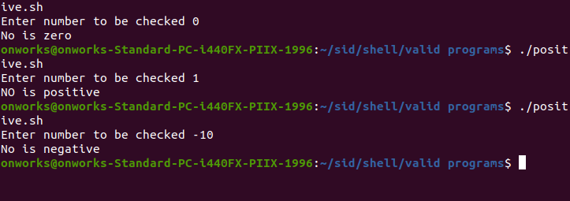

# Result

The program was executed and the result was successfully obtained. Thus CO3 was obtained